**ONLINE LEARNING(AI-AGENT)**

|  |  |
| --- | --- |
| **Reg.no** | **Names** |
| **231FA04486** | **Rajesh** |
| **231FA04367** | **yadavandra** |
| **231FA04111** | **Sivaram** |
| **231FA04832** | **Anjan kumar** |
| **231FA04480** | **Ravi teja** |

**Abstract :**

In the digital age, education has rapidly transitioned from traditional classroom environments to online platforms. This project aims to develop an interactive and user-friendly Learning Website that provides accessible, flexible, and effective educational content to students and learners worldwide.

The platform is designed to host a wide range of theoretical learning materials, including subject notes, tutorials, quizzes, and progress-tracking tools. Unlike typical video-centric platforms, this website emphasizes text-based learning content to support focused and distraction-free learning experiences.

Key features of the system include:

User authentication for secure access.

Course dashboard with categorized subjects.

AI-powered Chat Tutor to assist learners with doubts.

Progress tracking for user performance monitoring.

Quiz and assessment modules to evaluate learning outcomes.

**INTRODUCTION:**

The rapid advancement of digital technology has revolutionized the way people access and consume educational content. Traditional classroom-based learning, while still effective, often lacks flexibility and accessibility for many learners, especially in remote or underserved regions. In response to these limitations, online learning platforms have emerged as powerful tools to bridge educational gaps and promote continuous learning.

This project proposes the development of a Learning Website—an interactive, web-based platform designed to provide theoretical educational content to students, teachers, and self-learners. Unlike conventional e-learning portals that rely heavily on video-based instruction, this platform emphasizes text-based learning materials, including subject notes, tutorials, quizzes, and AI-assisted guidance. The goal is to make learning more accessible, distraction-free, and cost-effective, especially in regions where high-speed internet access is limited.

The platform is structured to support a wide range of subjects and educational levels. It includes features such as user registration and login, course dashboards, progress tracking, and an AI-powered Chat Tutor capable of answering user queries, giving hints, and providing explanations. Additionally, the system is mobile-responsive, ensuring usability across various devices such as smartphones, tablets, and laptops.

The Learning Website not only caters to individual learners but also serves as a valuable resource for educational institutions that wish to supplement their teaching with an online theoretical knowledge base. By integrating modern technologies such as artificial intelligence and cloud-based content delivery, the platform offers a scalable and customizable solution for contemporary education needs.

**Methodology**:

The development of the Learning Website was carried out using a structured and phased approach to ensure a robust, scalable, and user-friendly platform. This stage involved defining core features such as user authentication, content management, progress tracking, quiz functionality, and AI-based assistance.

Following this, the **system design phase** was undertaken to outline the website’s architecture. Wireframes and mockups were created for the user interface, and database schemas were planned for storing user profiles, course materials, and assessment data. A block diagram and data flow diagram (DFD) were developed to visually represent the structure and data interactions within the system.

Next, **frontend development** focused on building a responsive and intuitive user interface using technologies such as HTML, CSS, JavaScript, or frameworks like React. The design ensured accessibility across various devices including desktops, tablets, and smartphones. Concurrently, **backend development** was performed using platforms like Firebase or Node.js to manage user authentication, course data, and quizzes. RESTful APIs or Firebase services were used to enable seamless communication between the frontend and backend.

A significant feature of the platform was the integration of an **AI-powered Chat Tutor**, developed using natural language processing tools like OpenAI’s GPT or Google Dialogflow. This chatbot was designed to assist users by answering academic queries, navigating the platform, and providing quiz explanations, thereby enhancing the learning experience.

The system underwent rigorous **testing and debugging** to ensure functionality and usability. Unit and integration tests were conducted, and feedback from initial users was used to identify and resolve issues. Once stable, the platform was **deployed** on a cloud-based hosting service such as Firebase Hosting or Netlify, with domain configuration and SSL setup for secure access.

Finally, the website entered the **maintenance phase**, during which regular updates are made to content and system components. User analytics are monitored to improve performance, and new features are introduced based on feedback and evolving educational needs.

**Literature Review**

With the advent of internet technologies, the domain of education has witnessed a significant transformation through the development of online learning platforms. Various studies and existing systems have contributed to the conceptualization of effective learning websites. Early platforms like **Khan Academy** and **Coursera** demonstrated the potential of video-based learning in delivering quality education to a global audience. However, these systems also highlighted issues such as high bandwidth requirements and limited interactivity for theoretical learning.

Several research papers have emphasized the importance of **user-centered design** and **modular content delivery** in educational technology. For instance, authors have noted that systems offering **self-paced learning**, structured content, and **interactive assessments** tend to improve learning outcomes and user satisfaction. Furthermore, **text-based content**, when designed effectively, promotes deeper understanding by encouraging active reading, note-taking, and cognitive engagement, as supported by research in cognitive load theory.

Recent developments have focused on the integration of **Artificial Intelligence (AI)** in education, particularly through **AI tutors and chatbots**. Studies have shown that AI-powered systems can enhance personalized learning experiences by answering student queries, adapting to learning styles, and providing instant feedback. Platforms like **Duolingo** have implemented AI algorithms to personalize content difficulty, showing increased user retention and performance.

Additionally, the use of cloud-based technologies like **Firebase**, **AWS**, and **Google Cloud** for hosting educational content and managing user data has become standard practice. These platforms offer scalability, real-time updates, and secure data handling, which are crucial for modern educational websites.

In summary, the existing literature supports the development of learning platforms that are interactive, accessible, and adaptive. By drawing insights from both traditional and AI-enhanced systems.

**Technologies Used:**

The development of the Learning Website leverages a combination of modern web technologies and tools to ensure high performance, scalability, and a seamless user experience. For the **frontend development**, technologies such as **HTML5**, **CSS3**, and **JavaScript** were used to create a responsive and visually appealing user interface. In some implementations, frontend frameworks like **React.js** or **Vue.js** are adopted to enhance interactivity and manage complex UI components efficiently.

On the **backend**, **Node.js** and **Express.js** serve as the core technologies for handling server-side logic, managing API routes, and processing data requests. For projects requiring real-time features and rapid deployment, **Firebase** is used extensively. Firebase Authentication handles secure user login and registration, while **Firestore** or **Realtime Database** is employed for storing user data, course materials, quiz records, and progress tracking.

To incorporate AI-based features such as the chatbot tutor, **OpenAI's GPT models** or **Google Dialogflow** are integrated. These tools enable the system to understand natural language queries and provide intelligent responses to learners, simulating real-time assistance and personalized tutoring.

For content and media storage, **Firebase Storage** or **Cloudinary** may be used to host files such as PDFs, documents, and images. The project is deployed on hosting platforms like **Firebase Hosting**, **Netlify**, or **Vercel**, which provide fast and secure delivery of static and dynamic web pages.

Additional tools such as **Git** and **GitHub** are used for version control and collaborative development. The design of the UI/UX is often supported by tools like **Figma** or **Adobe XD**. For analytics and user tracking, **Google Analytics** is optionally integrated to monitor user behavior and improve the learning experience.

By combining these technologies, the Learning Website ensures a robust, responsive, and scalable platform that caters to both learners and educators effectively.

BLOCK DIAGRAMAS:

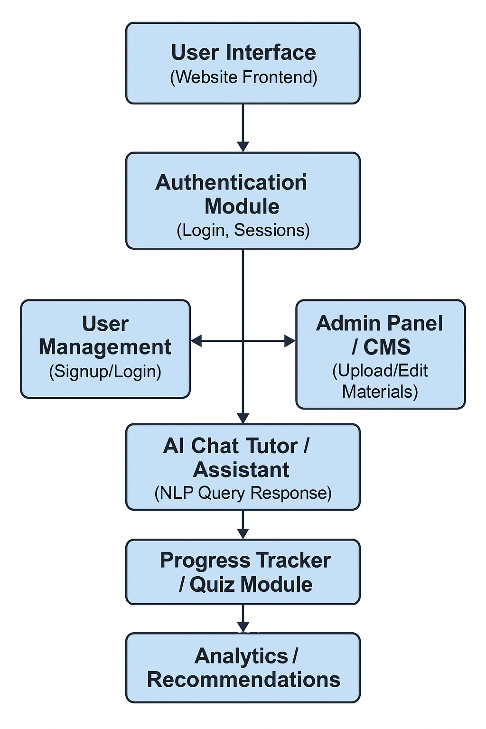

**OUTPUT:**

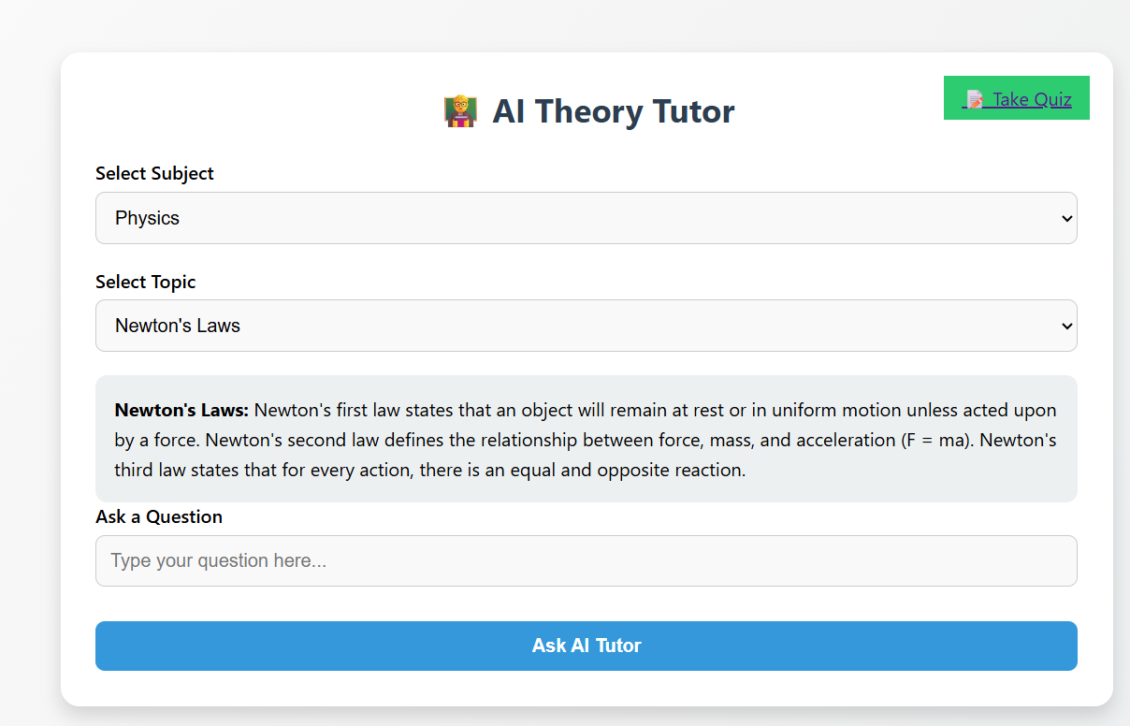

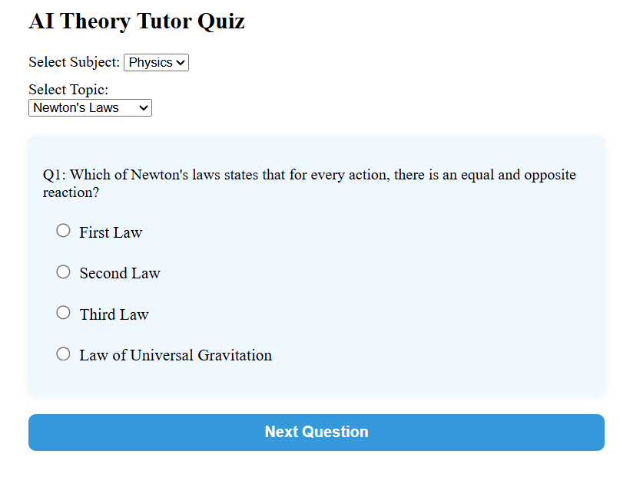

**CONCLUSION:**

The development of the Learning Website demonstrates the effective integration of modern web technologies and artificial intelligence to enhance the educational experience. By focusing on theoretical content delivery, personalized learning support, and interactive assessments, the platform provides a comprehensive and accessible learning environment for students. The modular structure ensures scalability and ease of maintenance, while features such as AI-driven chat support, progress tracking, and a user-friendly interface contribute to a more engaging and productive learning process.

This project not only addresses the limitations of traditional classroom learning and video-based platforms but also promotes self-paced, text-oriented education that is lightweight and accessible even with limited internet connectivity. The use of cloud-based services like Firebase enhances data handling, security, and deployment, making the platform reliable and efficient.

In conclusion, the Learning Website serves as a step forward in digital education by offering a practical, intelligent, and scalable solution tailored to the evolving needs of learners and educators. Future enhancements can include multilingual content, video integration, live classes, and gamification to further improve engagement and learning outcomes.

**REFERENCE:**

W3Schools. (2024). *HTML, CSS, JavaScript Tutorials*. Retrieved from [https://www.w3schools.com](https://www.w3schools.com/)